HIS-144 Topic 6 Primary Source List
Utilize the primary sources below to assist in completing the Topic 6 assignments and DQs.
Click on the links below to access the primary source. To return to the Table of Contents, click on the article title, in text, when finished.
Table of Contents:
Antislavery Letter by Member of the Liberty Party
The Freedmen’s Bureau Act of 1865
Harriet Beecher Stowe Portrays Slavery's Brutality
Niagara's Declaration of Principles, 1905
John Brown’s address to the court
John Brown: Primary Documents
Horace Mann: The Tenth Annual Report (1846) to the Massachusetts Legislature
Life and Works of Horace Mann
John Dewey: Democracy and Education
African American Perspectives: Pamphlets from the Daniel A. P. Murray Collection 1818-1907
Transcript of Morrill Act (1862)
Transcript of Northwest Ordinance (1787)
1965 Voting Rights Act
13th-19th Amendments
President Lyndon B. Johnson’s Commencement Address at Howard University, June 1965
George Fitzhugh: The Universal Law of Slavery
George Fitzhugh: Cannibals All! Or Slaves Without Masters
James Henry Hammond: “The ‘Mudsill’ Theory”
John C. Calhoun's "Slavery a positive good" (1837)

Antislavery Letter by Member of the Liberty Party (next page)

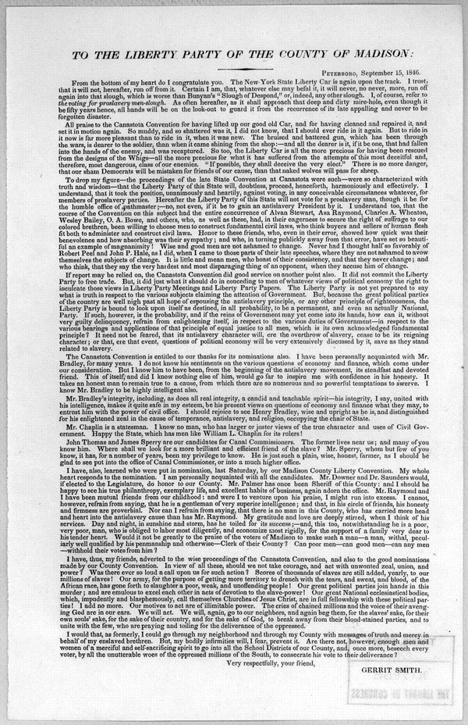
The Freedmen’s Bureau Act of 1865
March 3, 1865
CHAP. XC.—An Act to establish a Bureau for the Relief of Freedmen and Refugees.
Be it enacted by the Senate and House of Representatives of the United States of America in Congress assembled, That there is hereby established in the War Department, to continue during the present war of rebellion, and for one year thereafter, a bureau of refugees, freedmen, and abandoned lands, to which shall be committed, as hereinafter provided, the supervision and management of all abandoned lands, and the control of all subjects relating to refugees and freedmen from rebel states, or from any district of country within the territory embraced in the operations of the army, under such rules and regulations as may be prescribed by the head of the bureau and approved by the President. The said bureau shall be under the management and control of a commissioner to be appointed by the President, by and with the advice and consent of the Senate, whose compensation shall be three thousand dollars per annum, and such number of clerks as may be assigned to him by the Secretary of War, not exceeding one chief clerk, two of the fourth class, two of the third class, and five of the first class. And the commissioner and all persons appointed under this act, shall, before entering upon their duties, take the oath of office prescribed in an act entitled "An act to prescribe an oath of office, and for other purposes," approved July second, eighteen hundred and sixty-two, and the commissioner and the chief clerk shall, before entering upon their duties, give bonds to the treasurer of the United States, the former in the sum of fifty thousand dollars, and the latter in the sum of ten thousand dollars, conditioned for the faithful discharge of their duties respectively, with securities to be approved as sufficient by the Attorney-General, which bonds shall be filed in the office of the first comptroller of the treasury, to be by him put in suit for the benefit of any injured party upon any breach of the conditions thereof.
SEC. 2. And be it further enacted, That the Secretary of War may direct such issues of provisions, clothing, and fuel, as he may deem needful for the immediate and temporary shelter and supply of destitute and suffering refugees and freedmen and their wives and children, under such rules and regulations as he may direct.
SEC. 3. And be it further enacted, That the President may, by and with the advice and consent of the Senate, appoint an assistant commissioner for each of the states declared to be in insurrection, not exceeding ten in number, who shall, under the direction of the commissioner, aid in the execution of the provisions of this act; and he shall give a bond to the Treasurer of the United States, in the sum of twenty thousand dollars, in the form and manner prescribed in the first section of this act. Each of said commissioners shall receive an annual salary of two thousand five hundred dollars in full compensation for all his services. And any military officer may be detailed and
assigned to duty under this act without increase of pay or allowances. The commissioner shall, before the commencement of each regular session of congress, make full report of his proceedings with exhibits of the state of his accounts to the President, who shall communicate the same to congress, and shall also make special reports whenever required to do so by the President or either house of congress; and the assistant commissioners shall make quarterly reports of their proceedings to the commissioner, and also such other special reports as from time to time may be required.
SEC. 4. And be it further enacted, That the commissioner, under the direction of the President, shall have authority to set apart, for the use of loyal refugees and freedmen, such tracts of land within the insurrectionary states as shall have been abandoned, or to which the United States shall have acquired title by confiscation or sale, or otherwise, and to every male citizen, whether refugee or freedman, as aforesaid, there shall be assigned not more than forty acres of such land, and the person to whom it was so assigned shall be protected in the use and enjoyment of the land for the term of three years at an annual rent not exceeding six per centum upon the value of such land, as it was appraised by the state authorities in the year eighteen hundred and sixty, for the purpose of taxation, and in case no such appraisal can be found, then the rental shall be based upon the estimated value of the land in said year, to be ascertained in such manner as the commissioner may by regulation prescribe. At the end of said term, or at any time during said term, the occupants of any parcels so assigned may purchase the land and receive such title thereto as the United States can convey, upon paying therefor the value of the land, as ascertained and fixed for the purpose of determining the annual rent aforesaid.
SEC. 5. And be it further enacted, That all acts and parts of acts inconsistent with the provisions of this act, are hereby repealed.
APPROVED, March 3, 1865.
U.S., Statutes at Large, Treaties, and Proclamations of the United States of America, vol. 13 (Boston, 1866), pp. 507-9.
_________________________
Source: http://www.history.umd.edu/Freedmen/fbact.htm
Freedmen – ex-slaves

Insurrectionary – rebellious
Aforesaid – said or named before or above

Harriet Beecher Stowe Portrays Slavery's Brutality
Stowe, Harriet Beecher
1852

. . . "And now," said Legree, "come here, you Tom. You see I telled ye I didn't buy ye jest for the common work; I mean to promote ye and make a driver of ye; and tonight ye may jest as well begin to get yer hand in. Now, ye jest take this yer gal and flog her; ye've seen enough on't to know how."
"I beg Mas'r's pardon," said Tom, "hopes Mas'r won't set me at that. It's what I an't used to--never did--and can't do, no way possible."
"Ye'll larn a pretty smart chance of things ye never did know before I've done with ye!" said Legree, taking up a cowhide and striking Tom a heavy blow across the cheek, and following up the infliction by a shower of blows.
"There!" he said, as he stopped to rest, "now will ye tell me ye can't do it?"
"Yes, Mas'r," said Tom, putting up his hand to wipe the blood that trickled down his face. "I'm willin' to work night and day, and work while there's life and breath in me, but this yer thing I can't feel it right to do; and, Mas'r, I never shall do it--never!"
Tom had a remarkably smooth, soft voice, and a habitually respectful manner that had given Legree an idea that he would be cowardly and easily subdued. When he spoke these last words, a thrill of amazement went through everyone; the poor woman clasped her hands and said, "O Lord!" and everyone involuntarily looked at each other and drew in their breath, as if to prepare for the storm that was about to burst.
Legree looked stupefied and confounded; but at last burst forth--
"What! ye blasted black beast! tell me ye don't think it right to do what I tell ye! What have any of you cussed cattle to do with thinking what's right? I'll put a stop to it! Why, what do ye think ye are? May be ye think ye're a gentleman, master Tom, to be a telling your master what's right and what an't! So you pretend it's wrong to flog the gal!"
"I think so, Mas'r," said Tom, "the poor crittur's sick and feeble; 't would be downright cruel, and it's what I never will do, not begin to. Mas'r, if you mean to kill me, kill me; but as to my raising my hand agin anyone here, I never shall--I'll die first!"
Tom spoke in a mild voice but with a decision that could not be mistaken. Legree shook with anger; his greenish eyes glared fiercely and his very whiskers seemed to curl with passion; but, like some ferocious beast that plays with its victim before he devours it, he kept back his strong impulse to proceed to immediate violence and broke out into bitter raillery.
"Well, here's a pious dog, at last, let down among us sinners!--a saint, a gentleman, and no less, to talk to us sinners about our sins! Powerful, holy crittur, he must be! Here, you rascal, you make believe to be so pious--didn't you never hear out of yer Bible, 'Servants, obey yer masters'? An't I yer master? Didn't I pay down $1,200 cash for all there is inside yer old cussed black shell? An't yer mine, now, body and soul?" he said, giving Tom a violent kick with his heavy boot. "Tell me!"
In the very depth of physical suffering, bowed by brutal oppression, this question shot a gleam of joy and triumph through Tom's soul. He suddenly stretched himself up, and, looking earnestly to heaven, while the tears and blood that flowed down his face mingled, he exclaimed--
"No! no! no! my soul an't yours, Mas'r! You haven't bought it--ye can't buy it! It's been bought and paid for by one that is able to keep it--no matter, no matter, you can't harm me!"
"I can't!" said Legree, with a sneer, "we'll see--we'll see! Here, Sambo, Quimbo, give this dog such a breakin' in as he won't get over this month!"
The two gigantic Negroes that now laid hold of Tom, with fiendish exultation in their faces, might have formed no unapt personification of the powers of darkness. The poor woman screamed with apprehension and all arose as by a general impulse while they dragged him unresisting from the place. . . .

Credits: Harriet Beecher Stowe, Uncle Tom's Cabin (Boston: J. P. Jewett and Co., 1852), pp. 419-423.

Niagara's Declaration of Principles, 1905 http://glc.yale.edu/niagaras-declaration-principles-1905

John Brown’s address to the court http://www.pbs.org/wgbh/aia/part4/4h2943.html
John Brown: Primary Documents http://www.wvculture.org/history/jbexhibit/jbprimarydocuments.html

Horace Mann: The Tenth Annual Report (1846) to the Massachusetts Legislature; Mann makes the argument that education is a right. Read the Report for 1846 starting on page 523 https://archive.org/details/annualreportson00manngoog

Life and Works of Horace Mann https://archive.org/details/lifeandworkshor02manngoog

John Dewey: Democracy and Education http://www.gutenberg.org/files/852/852-h/852-h.htm

African American Perspectives: Pamphlets from the Daniel A. P. Murray Collection 1818-1907 http://memory.loc.gov/ammem/aap/aaphome.html

Transcript of Morrill Act (1862)
http://www.ourdocuments.gov/doc.php?doc=33&page=transcript

Transcript of Northwest Ordinance (1787)
http://www.ourdocuments.gov/doc.php?doc=8&page=transcript

1965 Voting Rights Act: http://www.ourdocuments.gov/doc.php?doc=100&page=pdf

13th-19th Amendments: http://www.archives.gov/exhibits/charters/constitution_amendments_11-27.html

President Lyndon B. Johnson’s Commencement Address at Howard University, June 1965 http://www.presidency.ucsb.edu/ws/?pid=27021
George Fitzhugh: The Universal Law of Slavery http://www.pbs.org/wgbh/aia/part4/4h3141t.html
George Fitzhugh: Cannibals All! Or Slaves Without Masters http://www.gutenberg.org/files/35481/35481-h/35481-h.htm
James Henry Hammond: “The ‘Mudsill’ Theory” http://www.pbs.org/wgbh/aia/part4/4h3439t.html
John C. Calhoun: "Slavery a positive good" (1837) http://search.credoreference.com.lopes.idm.oclc.org/content/entry/abcslavery/john_c_calhoun_s_slavery_a_positive_good_1837/0

